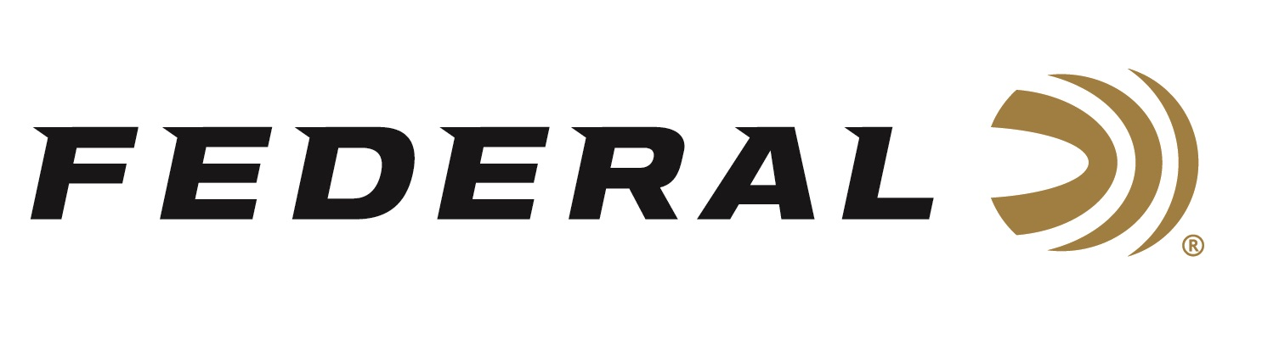

FOR IMMEDIATE RELEASE

The One and Only Buckmaster on the “It’s Federal Season” Podcast

ANOKA, Minnesota – November 18, 2021 – Jackie Bushman has been a mainstay of outdoors television since 1988 when he launched his deer hunting show, Buckmasters, on The Nashville Network (TNN). From its first episode, the show has maintained its popularity through network changes and today, Jackie still commands an audience with his southern charm and big monster buck stories airing on Outdoor Channel.

“Federal has partnered with Jackie Bushman for nearly thirty-five years,” said Jason Nash, Vice President of Marketing. “His longevity as a sponsored television host and ambassador is a great testimony to his popularity and Federal is proud to have our products loaded in his firearms for more than three decades.”

Episode #28 “The Buckmaster”
https://www.federalpremium.com/this-is-federal/podcast/

In the Tech Talk segment, Director of Product Development Adam Moser will give listeners insights to new shotshell and muzzleloader products coming in 2022, including a new offering in the revolutionary FireStick product. In the news and notes segment, with the holidays coming, make sure to check out www.federalpremium.com for a great holiday gift idea as well as learning when you can meet our ammunition teams during the winter consumer show season.

For this episode, besides listening on the Federal Premium website or Talk North podcast network, you can also subscribe to Federal Ammunition’s YouTube channel (https://www.youtube.com/user/federalpremiumammo) and tune in for the discussion.

Federal Ammunition can be found at dealers nationwide or purchased online direct from Federal. For more information on all products from Federal or to shop online, visit www.federalpremium.com.

Press Release Contact: JJ Reich
Senior Manager – Press Relations
E-mail: VistaPressroom@VistaOutdoor.com

About Federal Ammunition
Federal, headquartered in Anoka, MN, is a brand of Vista Outdoor Inc., an outdoor sports and recreation company. From humble beginnings nestled among the lakes and woods of Minnesota, Federal Ammunition has evolved into one of the world's largest producers of sporting ammunition. Beginning in 1922, founding president, Charles L. Horn, paved the way for our success. Today, Federal carries on Horn's vision for quality products and service with the next generation of outdoorsmen and women. We maintain our position as experts in the science of ammunition production. Every day we manufacture products to enhance our customers' shooting experience while partnering with the conservation organizations that protect and support our outdoor heritage. We offer thousands of options in our Federal Premium and Federal® lines-it's what makes us the most complete ammunition company in the business and provides our customers with a choice no matter their pursuit.

